Question 1:
$$Y_{t} = β_{0} + Y_{t-1}+ ε_{t}$$
$$⟺{∆Y}_{t}=β_{0}+\left(1-1\right)Y_{t-1}+ε_{t}$$
$$⇒The process is non-stationary$$
Question 2:
y1t (Mink) – ACF 4
y2t (Passengers) – ACF 1
y3t (Deaths) – ACF 2
y4t (Cow’s temp) – ACF 3

Question 3:
- Stock prices of Vinamilk — sheet VNM
- Data format
Price: %14.2fc
Td = Date: %td

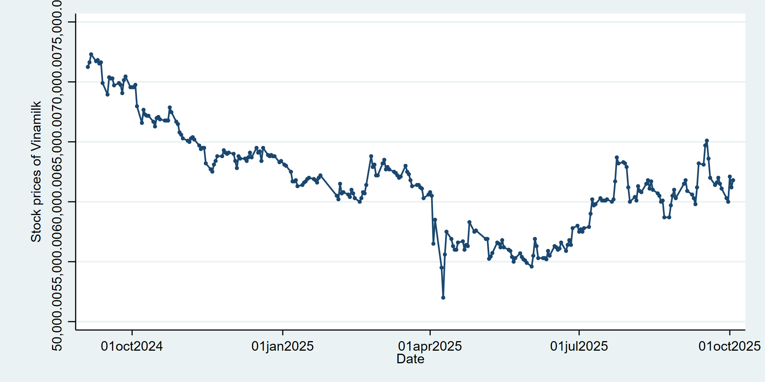
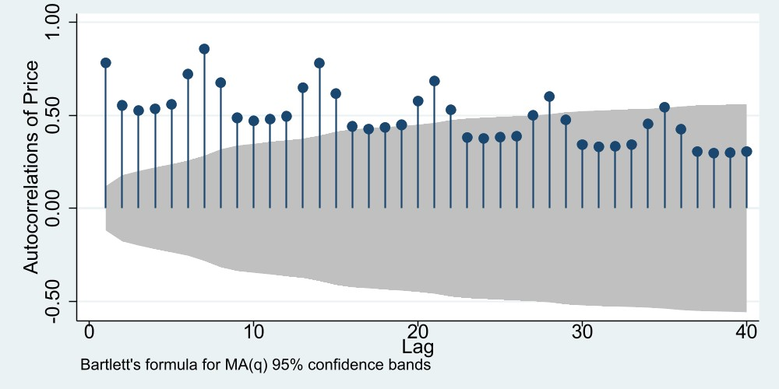
- Unit roots test
To examine whether the Vinamilk stock price series is stationary, the Augmented Dickey–Fuller (ADF) test was conducted.
The optimal lag length was determined using the “varsoc” command in Stata, which evaluates several information criteria (AIC, BIC, HQIC). Based on these criteria, 1 lag was selected for the ADF test.
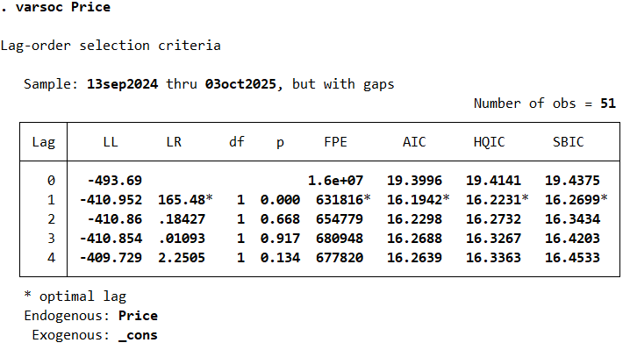
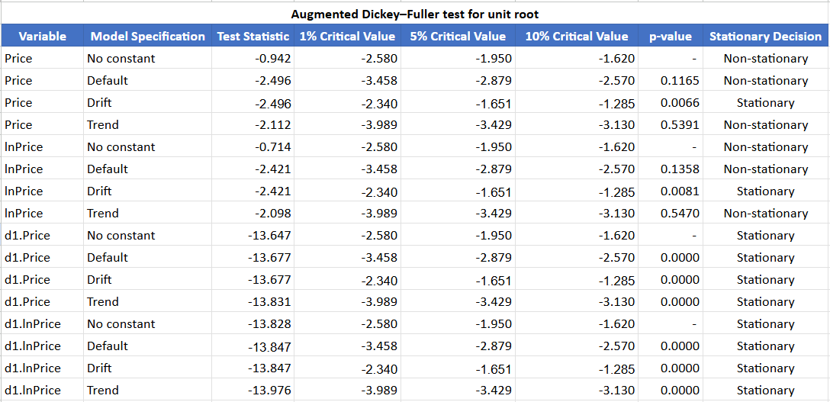
- Short interpretation
The Augmented Dickey–Fuller (ADF) test results show that both Price and ln(Price) are non-stationary at their levels, as their test statistics are higher than the critical values and p-values exceed 0.05. However, after taking the first differences, both series (d1.Price and d1.lnPrice) become highly stationary, with large negative test statistics and p-values of 0.0000. This indicates that each variable is integrated of order one, I(1). In other words, the original series contain a unit root but become stable after differencing once. Therefore, for further time-series modeling, the first-differenced or log-differenced data should be used to ensure stationarity.
- Seasonally adjusted US CPI — sheet PC
- Data format
CPI: %10.0g
Tq = Date: %tq

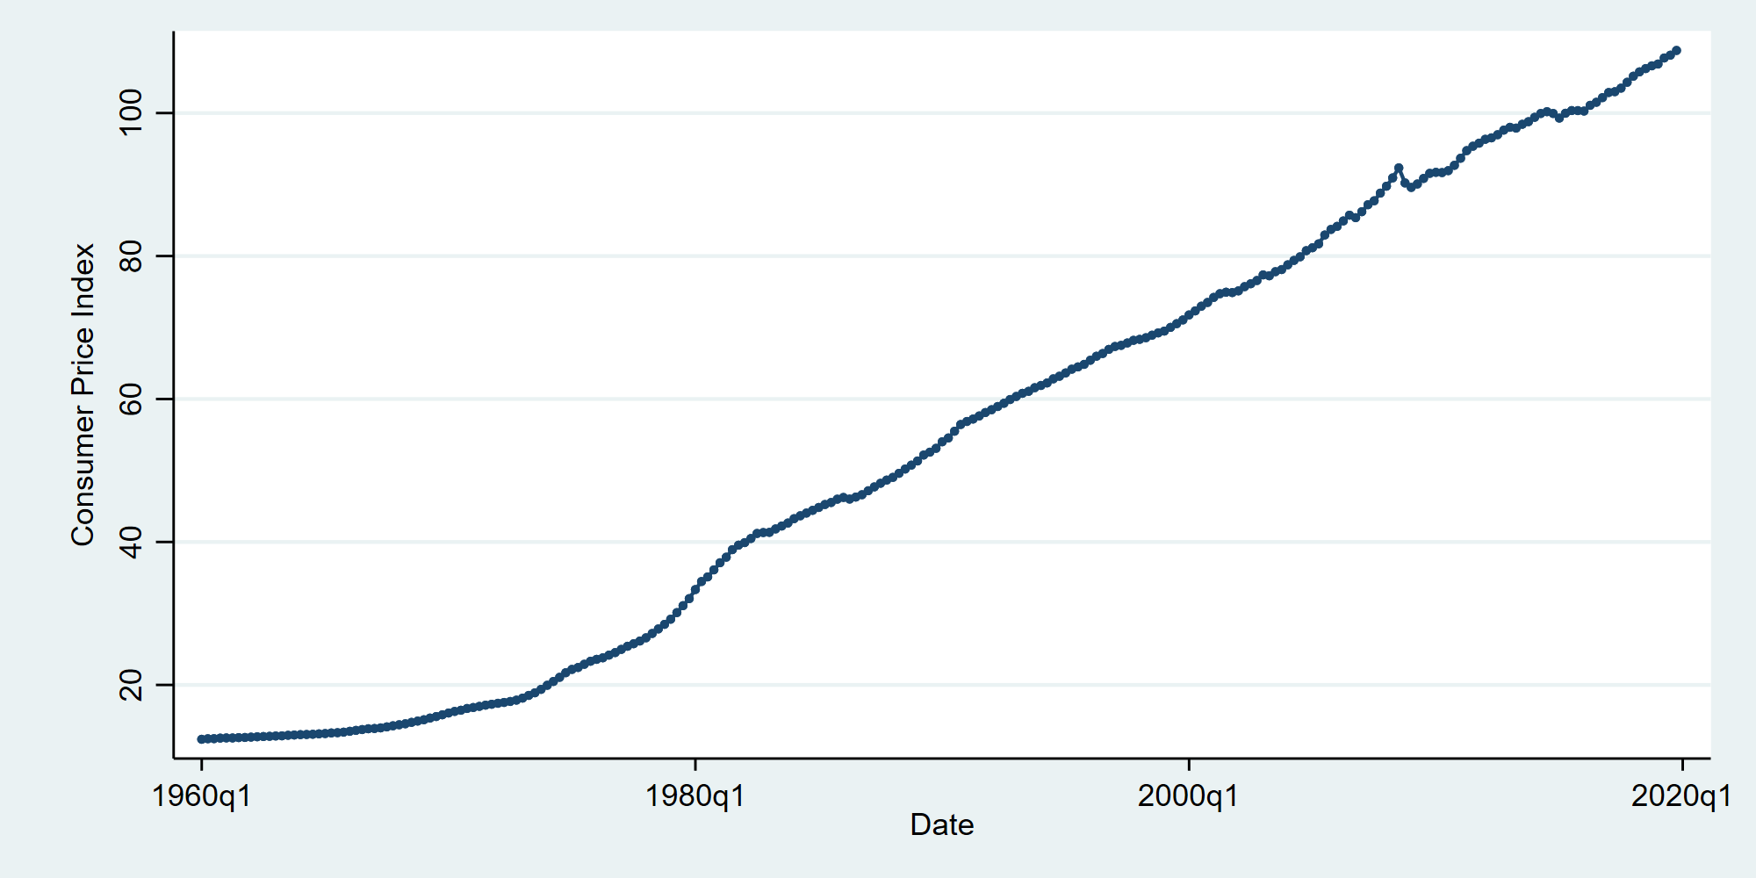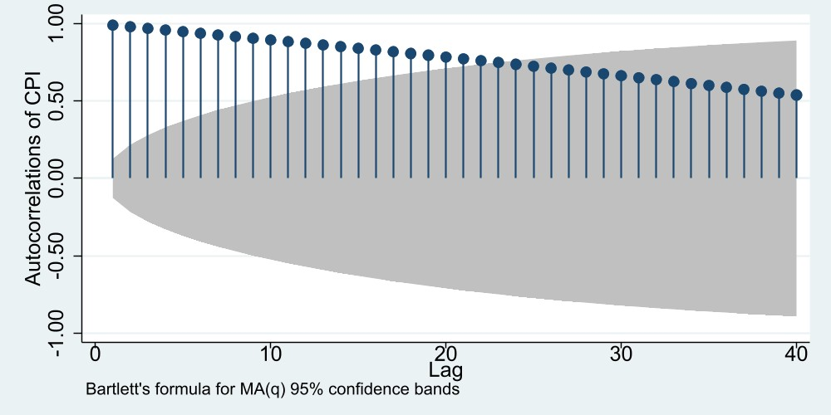
- Unit roots test
To examine whether the CPI is stationary, the Augmented Dickey–Fuller (ADF) test was conducted.
The optimal lag length was determined using the “varsoc” command in Stata, which evaluates several information criteria (AIC, BIC, HQIC). Based on these criteria, 4 lags was selected for the ADF test.
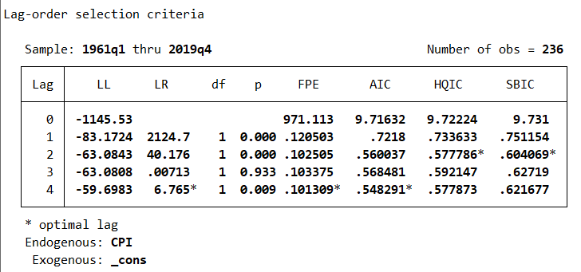
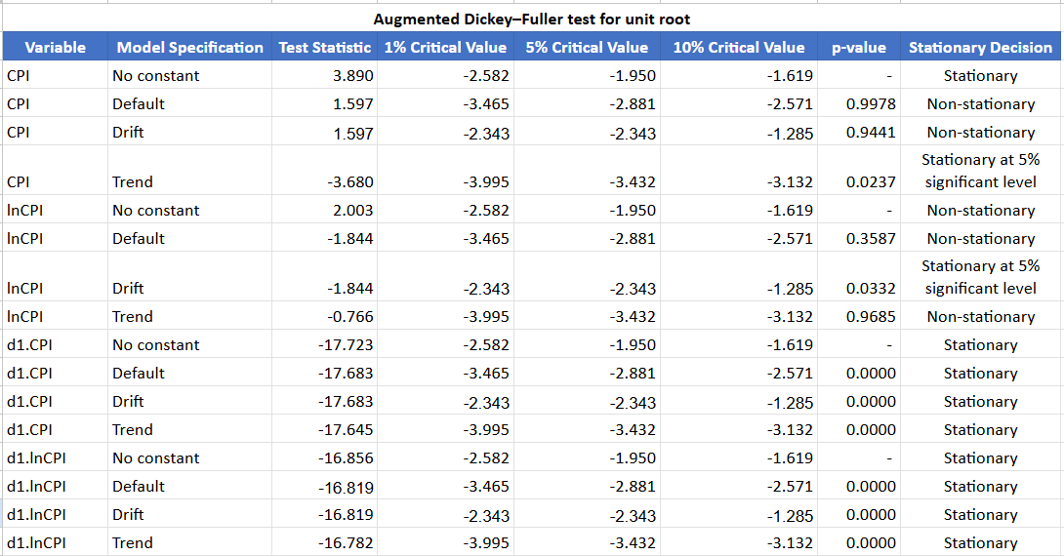

- Short interpretation
The Augmented Dickey–Fuller (ADF) test results indicate that the CPI and ln(CPI) series are mostly non-stationary at their levels, as their test statistics are higher than the critical values and have high p-values. However, the CPI (trend model) and ln(CPI) (drift model) show weak evidence of stationarity at the 5% significance level. After taking the first differences, both d1.CPI and d1.lnCPI become highly stationary, with very low p-values (0.0000) and large negative test statistics across all model specifications. This confirms that both series are integrated of order one, I(1). Therefore, for further analysis, the first-differenced or log-differenced versions of CPI should be used to ensure stationarity in the model.
- Seasonally adjusted US unemployment rate — sheet PC
- Data format
Unemployment: %10.0g
Td = Date: %td

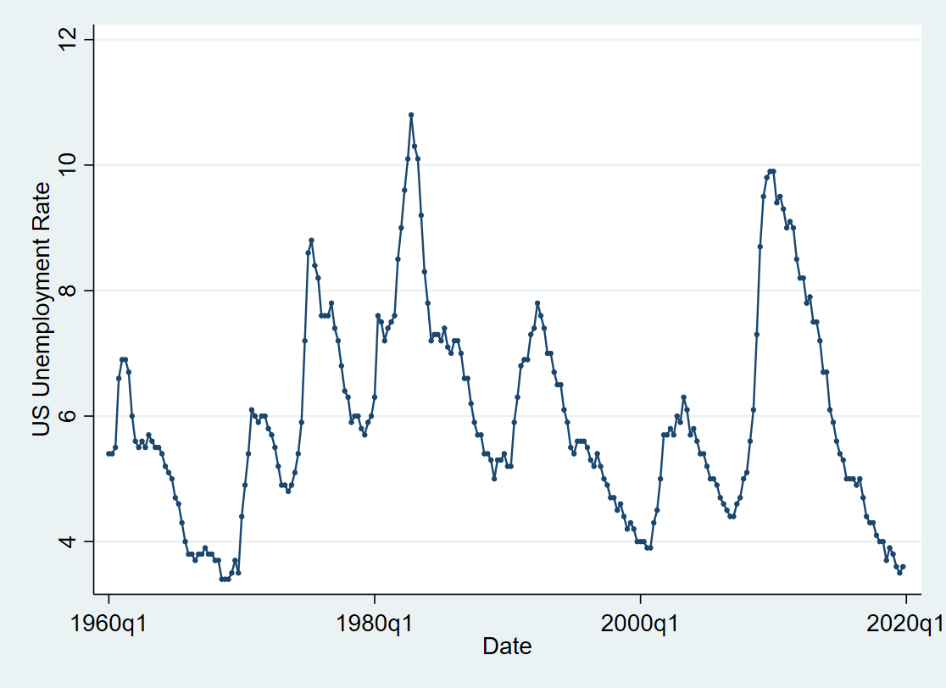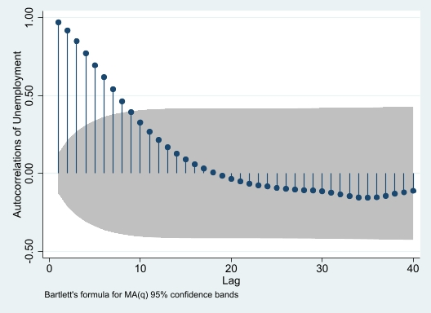
- Unit roots test
To examine whether the US Unemployment Rate is stationary, the Augmented Dickey–Fuller (ADF) test was conducted.
The optimal lag length was determined using the “varsoc” command in Stata, which evaluates several information criteria (AIC, BIC, HQIC). Based on these criteria, 3 lags was selected for the ADF test.
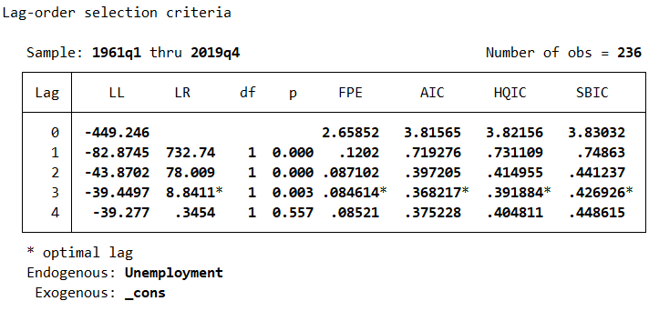
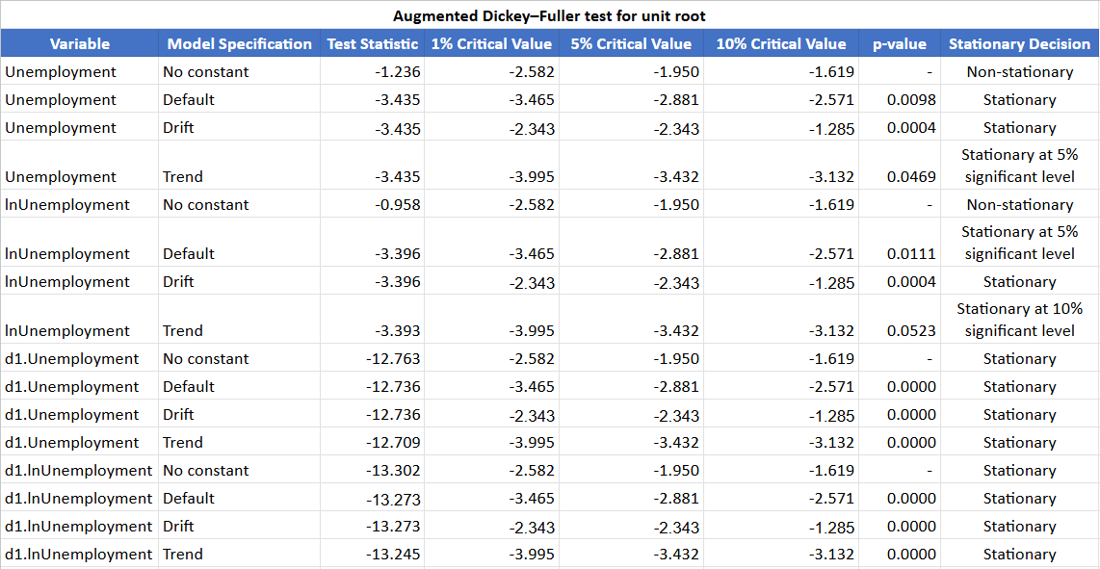
- Short interpretation
The Augmented Dickey–Fuller (ADF) test results show that the Unemployment and ln(Unemployment) series are mostly stationary at their levels, as their test statistics are more negative than the critical values and the p-values are below 0.05 in several model specifications. Specifically, both variables are stationary under the default, drift, and trend models at the 5% significance level. After first differencing, the series (d1.Unemployment and d1.lnUnemployment) remain strongly stationary, with extremely low p-values (0.0000). This confirms that the unemployment series are at least integrated of order zero, I(0), or possibly weakly I(1) depending on model selection. Overall, the results indicate that the unemployment data are generally stationary, and differencing is not strictly necessary for further analysis.
- Non-seasonally adjusted US unemployment rate — sheet PC
- Data format
Unemployment_non: %10.0g
Td = Date: %td

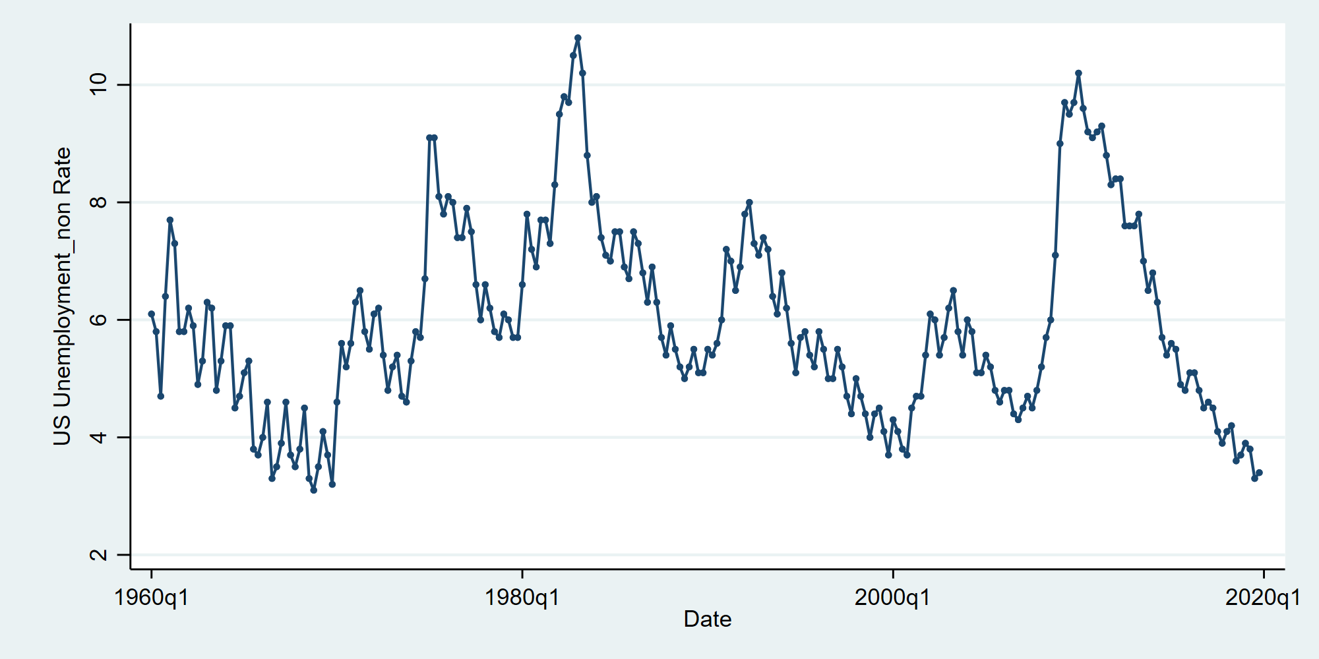
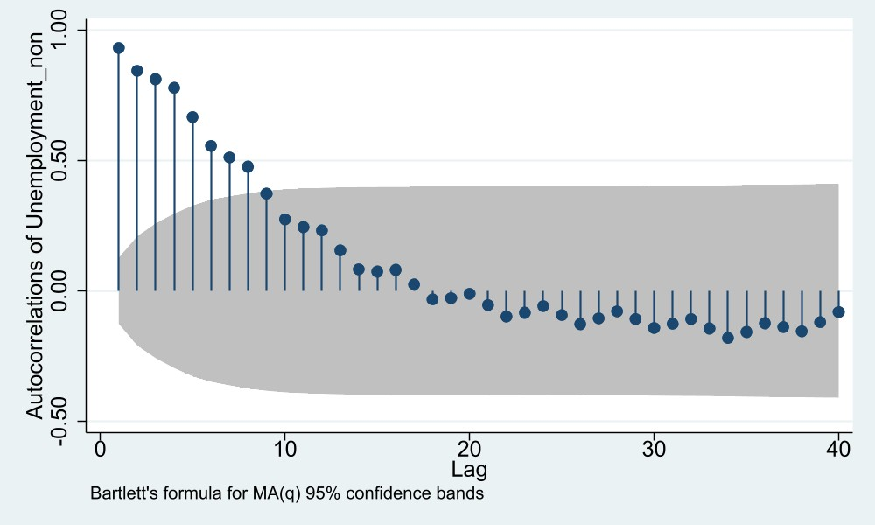
- Unit roots test
To examine whether the Non-seasonally adjusted US unemployment rate is stationary, the Augmented Dickey–Fuller (ADF) test was conducted.
The optimal lag length was determined using the “varsoc” command in Stata, which evaluates several information criteria (AIC, BIC, HQIC). Based on these criteria, 4 lags was selected for the ADF test.
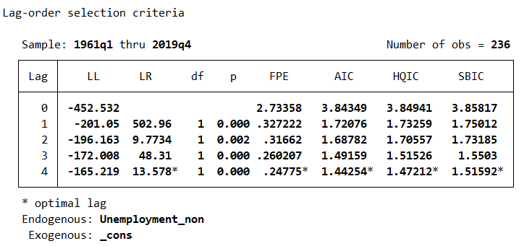

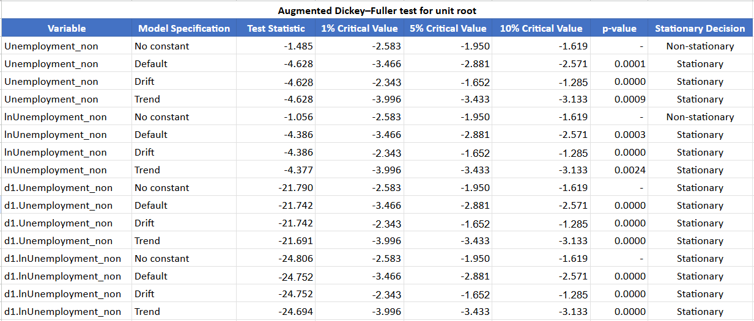
- Short interpretation
The Augmented Dickey–Fuller (ADF) test results indicate that both Unemployment_non and ln(Unemployment_non) are stationary at their levels across most model specifications. Their test statistics are well below the critical values, and p-values are highly significant (below 0.01), confirming rejection of the null hypothesis of a unit root. This means that these variables do not exhibit trends or stochastic drift over time. After first differencing, the variables remain strongly stationary, with extremely large negative test statistics and p-values of 0.0000. Overall, the results suggest that Unemployment_non and its logarithmic form are stationary (I(0)), so differencing is not necessary for subsequent time-series analysis.

